**SOCIETY MANAGMENET APP**

**Minor Project-II**

**(ENSI252)**

*Submitted in partial fulfilment of the requirement of the degree of*

**BACHELOR OF TECHNOLOGY**

*to*

**K.R Mangalam University**

by

**Harman Jeet Singh (230101252)**

**Abhay Gandotra (2301010262)**

**Fayyaz Khan (2301010261)**

**Pakhi Kumari (2301010213)**

Under the supervision of

**Ms. Gursimran Kaur Mr. Amit jii**

**Industry Mentor Mentor**



Department of Computer Science and Engineering

School of Engineering and Technology

K.R Mangalam University, Gurugram- 122001, India

April 2025

**CERTIFICATE**

This is to certify that the Project Synopsis entitled, “**SOCIETY MANAGEMENT APP** ”

submitted by “**Harman Jeet Singh(2301010252), Abhay Gandotra (2301010262) Fayyaz Khan(2301010261) and Pakhi Jha(2301010213)”** to **K.R Mangalam University, Gurugram, India,** is a record of bonafide project work carried out by them under my supervision and guidance and is worthy of consideration for the partial fulfilment of the degree of **Bachelor of Technology** in **Computer Science and Engineering** of the University.

**Type of Project**

**Industry**

Signature of Internal supervisor

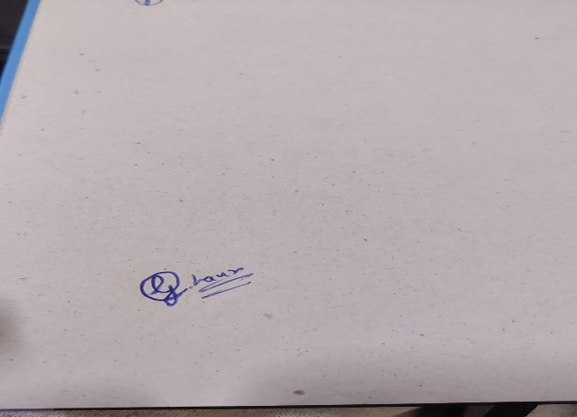

Signature of Project Coordinator

Date: 3rd April 2025

**INDEX**

|  |  |  |
| --- | --- | --- |
|  | Abstract | Page No. |
|  | Introduction |  |
|  | Motivation |  |
| 4. | LITERATURE REVIEW |  |
| 5 | Gap Analysis |  |
| 6 | Problem Statement |  |
| 7 | Objectives |  |
| 8 | Methodology |  |
| 9 | Data Description |  |
| 10 | Tools and equipment utilized |  |
| 11 | Environmental Setup |  |
| 12 | Hardware and Requirement |  |
| 13 | Result and Discussions |  |
| 14 | References |  |

**1.ABSTRACT**

Managing residential societies traditionally involves manual processes, communication gaps, inefficient service coordination, and delayed complaint resolution, causing inconvenience to residents and administrators alike. Society Management App proposes a centralized digital solution that transforms society management through an easy-to-use mobile application. This app streamlines communication, enables digital booking for essential services, facilitates real-time complaint tracking, and fosters community engagement through event updates and digital notices. Built using an agile methodology, the solution employs a modern tech stack including Flutter/React Native for the frontend, Node.js/Django for the backend, and Firebase/SQL for data management. By digitizing society operations, Society Management aims to enhance transparency, improve service efficiency, strengthen security, and create a connected, smart living environment for residents.

**KEYWORDS**: Society Management, Mobile App, Digital Services, Community Engagement, Agile Development, Smart Living.

**2.INTRODUCTION**

The management of residential societies has traditionally been a manual and fragmented process, heavily dependent on physical interactions, paper notices, and word-of-mouth communication. Over time, as societies grew larger and more complex, these traditional methods began to show significant limitations. Delayed service coordination, inefficient complaint resolution, poor communication between residents and management, and lack of transparency have become common issues faced by many societies.

In parallel, the rapid advancement of technology has transformed various sectors, improving efficiency, transparency, and user experience. Mobile applications and digital platforms have revolutionized how people interact with services — from banking to healthcare to transportation. However, the management of residential communities has largely remained underserved in this digital transformation journey.

Recognizing this gap, Society Management was conceptualized as a comprehensive digital solution tailored to the unique needs of residential societies. The aim is to bring all aspects of society management — communication, maintenance requests, service bookings, complaint management, community engagement, and security — under one unified platform.

By leveraging modern technologies like mobile app development (Flutter/React Native), cloud databases (Firebase/SQL), and real-time notification systems (Firebase Cloud Messaging), Society Management seeks to enhance operational efficiency, ensure quick service delivery, and foster a stronger sense of community. It represents a step toward creating smarter, digitally connected societies that prioritize convenience, transparency, and resident satisfaction.

**Table 1. Existing Challenges in Society Management**

|  |  |  |  |  |  |  |  |  |  |  |  |  |  |  |  |  |  |  |  |  |  |  |  |  |
| --- | --- | --- | --- | --- | --- | --- | --- | --- | --- | --- | --- | --- | --- | --- | --- | --- | --- | --- | --- | --- | --- | --- | --- | --- |
| |  |  |  |  | | --- | --- | --- | --- | | **S. No.** | **Area** | **Traditional Approach** | **Challenges Faced** | | 1 | Communication | Notice Boards, Word-of-Mouth | Delayed updates, information gaps | | 2 | Service Coordination | Manual service booking (calls, visits) | Inefficient scheduling, no tracking | | 3 | Complaint Resolution | Registers, Verbal Complaints | No tracking, delayed responses | | 4 | Community Engagement | Flyers, Posters | Limited reach, poor participation | | 5 | Payment and Billing | Cash/Cheques | Lack of transparency, record issues | |

**Table 2: Features of Society Management App**

|  |  |  |  |  |  |  |  |  |  |  |  |  |  |  |  |  |  |  |
| --- | --- | --- | --- | --- | --- | --- | --- | --- | --- | --- | --- | --- | --- | --- | --- | --- | --- | --- |
| |  |  |  | | --- | --- | --- | | **Feature** | **Description** | **Impact** | | Instant Communication | Digital notices and alerts to residents | Reduces information gaps, keeps residents updated in real-time | | Service Booking | Book electricians, plumbers, etc., via app | Simplifies maintenance service access | | Complaint Management | Track and resolve complaints with status updates | Faster response, better transparency | | Community Events | Announcements and RSVP for events | Boosts engagement and participation | | Digital Payment Integration | Online payment for maintenance and other dues | Ensures easy and transparent transactions | |

**Table 3: Technology Stack Used**

|  |  |  |  |  |  |  |  |  |  |  |  |  |  |  |  |  |  |  |
| --- | --- | --- | --- | --- | --- | --- | --- | --- | --- | --- | --- | --- | --- | --- | --- | --- | --- | --- |
| |  |  |  | | --- | --- | --- | | **Component** | **Technology Options** | **Purpose** | | Frontend | Flutter / React Native | Mobile App Interface | | Backend | Node.js / Django | Server-side Logic and API Management | | Database | Firebase / SQL | Data Storage and Retrieval | | Payment Gateway | Razorpay / Stripe | Online Payment Processing | | Notifications | Firebase Cloud Messaging | Real-time Updates and Alerts | |

**Table 4: Expected Impact on Community**

|  |  |  |  |  |  |  |  |  |  |  |  |  |  |  |  |  |  |  |  |  |  |  |  |  |
| --- | --- | --- | --- | --- | --- | --- | --- | --- | --- | --- | --- | --- | --- | --- | --- | --- | --- | --- | --- | --- | --- | --- | --- | --- |
| |  |  |  |  | | --- | --- | --- | --- | | **S. No.** | **Area** | **Before Society Management** | **After Society Management** | | 1 | Communication | Slow, manual, scattered | Instant, centralized, transparent | | 2 | Service Management | Unorganized, no tracking | Digital booking, status updates | | 3 | Complaint Handling | Manual registers, no accountability | Real-time tracking and resolution | | 4 | Payments | Manual, error-prone | Online, automated, secure | | 5 | Community Involvement | Limited to physical posters | App-based announcements, wider participation | |

**3.MOTIVATION**

In today’s fast-paced and digitally connected world, the traditional methods of managing residential societies have become increasingly inefficient and outdated. Physical notice boards, manual complaint handling, and verbal communication are prone to mismanagement, communication gaps, and delayed service delivery, leading to dissatisfaction among residents.

As urbanization continues to grow, there is a clear need for smarter, more streamlined systems that cater to the everyday needs of a community. Residents today expect quick access to information, seamless booking of essential services, real-time complaint resolution, transparent financial transactions, and active community engagement — all through digital platforms

.

Inspired by the growing demand for smarter living solutions, the Society Management project was envisioned to bridge the gap between residents and society management. The aim is to create a centralized, user-friendly mobile application that simplifies operations, fosters stronger communication, and builds a connected community.

By leveraging modern technologies like mobile app development, real-time notifications, online payments, and cloud data management, Society Management hopes to transform traditional residential societies into smart, efficient, and vibrant communities. The project is motivated by the vision of improving the quality of life for residents and making society administration transparent, efficient, and future-ready.

**4.LITERATURE REVIEW**

**Review of existing literature**

A strong body of research and real-world applications show that digitization significantly improves community management by enhancing communication, service coordination, and resident satisfaction. In this review, several related studies and existing systems are analyzed to highlight their contributions, limitations, and relevance to the Society Seva project.

### **1. Smart Community Management: Digital Solutions for Residential Societies**

**Source**: Brown, T. (2020), Springer

This research emphasizes the role of digital platforms in transforming community management. It explains how mobile apps and IoT technologies streamline service requests, issue handling, and financial transactions. A key takeaway is that centralized communication and real-time tracking significantly improve trust and transparency within societies.  
**Relevance**: Society Management adopts a similar centralized model for communication and service booking.

### **2. Enhancing Residential Living with IoT and Mobile Applications**

**Source**: Smith, J., & Patel, R. (2019), Journal of Smart City Technologies

This study shows how IoT devices and mobile applications can help automate tasks like visitor management, service requests, and complaint logging. However, it notes that user-friendly design and security measures are crucial to achieving widespread adoption.  
**Relevance**: Society Management prioritizes a simple and intuitive user interface while maintaining data security.

### **3. Flutter Documentation by Google Developers**

**Source**: Google Developers (n.d.)

Flutter provides a modern toolkit for building natively compiled applications for mobile from a single codebase. It supports faster UI development and beautiful app designs, critical for user engagement.  
**Relevance**: Flutter is considered for Society Management to ensure cross-platform availability with responsive, attractive interfaces.

### **4. Node.js and Backend Development**

**Source**: Mozilla Developer Network (MDN)

Node.js is recognized for its efficient server-side operations and real-time capabilities, making it suitable for apps that require constant updates, such as live notifications for complaints or events.  
**Relevance**: Society Management backend may use Node.js for scalable, real-time support.

### **5. Firebase Cloud Messaging for Real-time Updates**

**Source**: Firebase (n.d.)

Firebase Cloud Messaging (FCM) is a widely used service for sending push notifications to mobile devices. It ensures real-time delivery of important updates like service booking confirmations, complaint status changes, or event announcements.  
**Relevance**: Society Management incorporates FCM to keep residents instantly informed.

### **6. Online Payment Integration Guide**

**Source**: Stripe (n.d.)

Stripe provides robust APIs for integrating secure online payment gateways into applications. Easy-to-use payment solutions are critical for allowing residents to pay maintenance charges and other fees through the app.  
**Relevance**: Payment gateways like Stripe or Razorpay are integrated into Society Management for seamless financial transactions.

**Table 2. LITERATURE REVIEW/COMPARITIVE WORK**

### **Comparative Analysis of Existing Systems**

|  |  |  |  |  |  |  |  |  |  |  |  |  |  |  |  |  |  |  |  |  |  |  |  |  |
| --- | --- | --- | --- | --- | --- | --- | --- | --- | --- | --- | --- | --- | --- | --- | --- | --- | --- | --- | --- | --- | --- | --- | --- | --- |
| | **Feature/Platform** | **Traditional Methods** | **Existing Smart Solutions** | **Society** Management **(Proposed)** | | --- | --- | --- | --- | | Communication | Notice boards, word-of-mouth | App notifications, emails | Real-time in-app notifications | | Service Booking | Manual calls/visits | Online portals (some societies) | App-based instant service booking | | Complaint Management | Registers/manual follow-up | Ticketing systems (few apps) | Real-time tracking with updates | | Community Engagement | Flyers/posters | Event apps, WhatsApp groups | In-app community interaction | | Payment & Transactions | Cash, cheques | Limited online options | Secure in-app digital payments | |

**5.GAP ANALYSIS**

Despite the growing number of digital solutions aimed at improving society management, several key challenges and inefficiencies still persist. Existing systems often focus on isolated functionalities — such as online payment or basic complaint tracking — but fail to provide an all-in-one integrated platform that addresses all critical aspects of residential society management in a user-friendly manner.

Through the review of current solutions and practices, the following major gaps have been identified:

|  |  |  |  |  |  |  |  |  |  |  |  |  |  |  |  |  |  |  |  |  |  |  |  |  |  |  |  |  |  |  |  |  |  |  |  |  |
| --- | --- | --- | --- | --- | --- | --- | --- | --- | --- | --- | --- | --- | --- | --- | --- | --- | --- | --- | --- | --- | --- | --- | --- | --- | --- | --- | --- | --- | --- | --- | --- | --- | --- | --- | --- | --- |
| |  |  |  |  | | --- | --- | --- | --- | | **Aspect** | **Existing Systems** | **Identified Gaps** | **Society Management Solution** | | Communication | Notices, WhatsApp groups, emails | Delayed updates, lack of centralized platform | Instant app notifications and centralized communication | | Service Booking | Manual coordination, occasional online portals | No structured digital booking, lack of service history | In-app service booking with history and tracking | | Complaint Management | Verbal complaints, manual registers | No tracking, delays in response, lack of accountability | Real-time complaint tracking with status updates | | Community Engagement | Flyers, posters, scattered event information | Low participation, outdated methods | Digital event updates, RSVP options, discussions | | Payment and Financial Transactions | Cash or cheque collection | Insecure, tedious, manual tracking | Secure in-app online payments with receipts | | Transparency and Tracking | Manual systems, limited visibility for residents | Residents unaware of complaint/service statuses | Transparent dashboard for residents and management | | User Experience | Complicated portals, limited mobile accessibility | Poor app usability, low resident engagement | Simple, mobile-first app with intuitive UI/UX | | Real-Time Notifications | Rare or delayed alerts | No instant alerts for service bookings, complaints, or events | Real-time push notifications using Firebase Cloud Messaging | |

# **How Society Management App Addresses These Gaps:**

Provides a **single unified mobile app** for all society-related activities.

Ensures **real-time updates** and **instant notifications** for better resident engagement.

Enables **secure and convenient online payments** for maintenance and services.

Offers a **simple, intuitive, and accessible user interface** for residents of all age groups.

Promotes **transparency and accountability** through complaint status tracking and service logs.

**6.PROBLEM STATEMENT**

Managing a residential society involves a wide range of activities — from handling service requests, complaints, and maintenance tasks to ensuring effective communication between residents and administration. Traditionally, these processes are managed manually through notice boards, physical registers, word-of-mouth communication, or informal messaging groups.

This manual and fragmented approach leads to several challenges:

**Communication Gaps**: Important updates may not reach all residents in a timely manner.

**Inefficient Service Coordination**: Booking household services such as electricians, plumbers, or maids is often slow, unreliable, and poorly organized.

**Delayed Complaint Resolution**: Lack of a structured complaint system results in delayed response times and poor tracking of issues.

**Limited Community Engagement**: Outdated methods such as physical event posters and verbal invitations reduce community participation.

**Lack of Transparency and Accountability**: Residents have little visibility into the status of their complaints, service requests, and society activities.

**Cumbersome Financial Transactions**: Manual collection of maintenance charges and fees often leads to discrepancies and inconvenience.

In the age of digital transformation, there is a pressing need for an integrated, user-friendly, and real-time digital solution that addresses these inefficiencies.

Thus, the **Society Management App** project aims to develop a centralized mobile application that:

Streamlines communication,

Enables seamless service booking,

Provides real-time complaint tracking,

Facilitates community engagement,

Supports secure online payments, and

Enhances overall transparency and efficiency in society management.

**7.OBJECTIVES**

The primary objective of the Society Management project is to develop an integrated, user-friendly mobile application that transforms and digitizes the management of residential societies. The app aims to simplify operations, enhance resident experience, and foster better community engagement.

The specific objectives of the project are:

1. **Streamline Communication**
   * Provide a centralized platform for society-wide announcements, updates, and notifications.
   * Ensure instant delivery of important information to all residents via real-time alerts.
2. **Enable Digital Service Bookings**
   * Allow residents to book household services such as maids, electricians, and plumbers through the app.
   * Maintain a record of service requests for future reference and tracking.
3. **Simplify Complaint Management**
   * Implement an easy-to-use complaint lodging system with real-time tracking and status updates.
   * Improve accountability and ensure quicker resolution of complaints.
4. **Enhance Community Engagement**
   * Facilitate event announcements, RSVP features, polls, and group discussions within the app.
   * Promote a stronger sense of community by enabling smooth interactions among residents.

**Implement Secure Online Payments**

* + Integrate trusted payment gateways (Razorpay/Stripe) for maintenance fee collection and other transactions.
  + Ensure transparency in financial dealings with digital receipts and transaction history.

1. **Promote Transparency and Trust**
   * Allow residents to view the status of their service requests, complaints, and payments.
   * Empower both residents and management committees with clear records and dashboards.
2. **Offer a Simple and Intuitive User Experience**
   * Design an attractive, accessible, and responsive app interface suitable for users of all age groups.
   * Ensure ease of navigation and usability to encourage high adoption rates.

**8. METHODOLOGY**

The development of the Society Management mobile application follows a structured and iterative approach to ensure effective design, development, and deployment. The **Agile Methodology** is used to promote continuous improvement, flexibility, and user feedback integration throughout the project lifecycle

## **Agile Development Approach**

* The project is divided into multiple short iterations (sprints), each delivering functional modules.
* After every sprint, user feedback is collected and integrated into the next development phase to ensure continuous enhancement.

|  |
| --- |
| Problem Identification  ↓  Requirement Gathering  ↓  System Design (UI/UX + Database Architecture)  ↓  Development Phase (Frontend + Backend)  ↓  Testing & Debugging  ↓  Deployment  ↓  User Feedback & Final Enhancements  ↓  Launch |

**9. Data Description**

### **Data Description for Society Management App**

**User Data:**

**Fields:**

* + Name
  + Email ID
  + Phone Number
  + Apartment Number / House Details
  + Role (Resident, Admin, Security)

**Purpose:**

* + To authenticate users and personalize services.

**Service Booking Data:**

**Fields:**

* + Service Type (Plumber, Electrician, Maid, etc.)
  + Requested Date and Time
  + Service Provider Details
  + Status (Pending, Approved, Completed)

**Purpose:**

* + To manage and track essential service requests efficiently.

**Complaint and Feedback Data:**

**Fields:**

* + Complaint Title
  + Description
  + Category (Water, Electricity, Maintenance, etc.)
  + Status (New, In Progress, Resolved)
  + Response Logs

**Purpose:**

* + To handle and resolve resident complaints systematically.

**Payment Data:**

**Fields:**

* + Transaction ID
  + User ID
  + Amount Paid
  + Payment Method (UPI, Card, Net Banking)
  + Date and Time

**Purpose:**

* + To track maintenance fees, service charges, or event participation fees.

**Notification Data:**

**Fields:**

* + Message Content
  + Target Audience (All Residents, Specific Blocks, Individual)
  + Date and Time Sent

**Purpose:**

* + To send instant announcements, alerts, or updates to residents.

**Community Engagement Data:**

**Fields:**

* + Event Name
  + Event Description
  + Date and Time
  + Participants List

**Purpose:**

* + To boost community participation through digital event management.

**10.Details of tools, software, and equipment utilized.**

**PLATFORM USED**

### **Details of Tools, Software, and Equipment**

**1. Development Tools:**

* **Frontend:**
  + **Flutter** (for cross-platform mobile app development)
  + **React Native** (alternative for hybrid app development)

* **Backend:**
  + **Node.js** (server-side JavaScript runtime)
  + **Django** (alternative backend framework using Python)

**2. Database Systems:**

* **Firebase Realtime Database** (for cloud-based real-time syncing)
* **SQL Database** (for structured and relational data storage)

**3. Payment Integration:**

* **Razorpay** (Indian payment gateway for fast online transactions)
* **Stripe** (international payment gateway option)

**4. Notification Services:**

* **Firebase Cloud Messaging (FCM)** (for sending real-time notifications and updates to users)

**5. Project Management and Methodology:**

* **Agile Methodology** (iterative development with continuous feedback and improvements)
* **Trello** / **Jira** (for task and sprint management — optional based on team choice)

**6. Design and Prototyping Tools:**

* **Figma** (for UI/UX design and prototyping)
* **Adobe XD** (alternative for detailed mobile app designs)

**7. Testing Tools:**

* **Android Studio Emulator** / **Xcode Simulator** (for mobile app testing)
* **Postman** (for API testing and backend validation)

**8. Equipment:**

* **Laptops/Desktops** with:
  + Minimum 8GB RAM (recommended for smooth development)
  + Internet connectivity (for Firebase, version control, and testing)
* **Smartphones/Tablets** (Android and iOS devices for real-world testing)

**11.ENVIRONMENTAL SETUP**

## **1. Development Environment**

* **Operating System:**
  + Windows 10/11, macOS, or Linux (Ubuntu preferred for Node.js/Django servers)
* **IDE and Editors:**
  + **Visual Studio Code** (recommended for Flutter, React Native, Node.js)
  + **Android Studio** (for Flutter development and emulation)
  + **PyCharm** (if using Django for backend)
* **Version Control:**
  + **Git** installed and configured
  + **GitHub** or **GitLab** repository for project collaboration and source control

## **2. Software Installations**

* **Frontend:**
  + Flutter SDK (with PATH setup)
  + React Native CLI (with Node.js and npm installed)
  + Dart SDK (if using Flutter)
* **Backend:**
  + Node.js (v14 or above) and npm/yarn
  + Django (with Python 3.8+)
* **Database:**
  + Firebase Project Setup (Console Access)
  + SQL Server/MySQL Workbench (optional for structured data)
* **Payment Gateways:**
  + Razorpay or Stripe API credentials setup
* **Notification Services:**
  + Firebase Cloud Messaging (API Key and Configuration)

## **3. Mobile App Testing Environment**

* **Android Emulator** (through Android Studio)
* **Xcode Simulator** (for iOS apps — Mac only)
* **Physical Devices:**
  + Android phones (OS 9 or later)
  + iPhones (iOS 13 or later)

## **4. Deployment Environment**

* **Hosting Platforms:**
  + Firebase Hosting (for static frontend apps, optional)
  + Heroku / AWS EC2 / Render.com (for backend server deployment)
* **Domain Management:**
  + Custom domain setup (optional for final launch)
* **SSL Certificates:**
  + Use Let’s Encrypt for HTTPS security (if self-hosting backend)

## **5. Tools and Extensions**

* VS Code Extensions:
  + Flutter
  + Dart
  + ESLint (for React Native)
  + Prettier (for code formatting)
* Postman (for API testing)
* Firebase CLI (for deploying Firebase services)

**12.HARDWARE REQUIREMENTS**

## . Development Machines

* **Processor:**
  + Intel i5 8th Gen or higher / AMD Ryzen 5 or higher
* **RAM:**
  + Minimum 8 GB RAM (recommended 16 GB for smooth multitasking)
* **Storage:**
  + 256 GB SSD or higher (preferred over HDD for faster performance)
* **Graphics:**
  + Integrated GPU sufficient (for basic development)
  + Dedicated GPU optional (for faster emulator/simulator performance)

## **2. Mobile Devices (for App Testing)**

* **Android Devices:**
  + Minimum Android 9 (Pie) or later
* **iOS Devices:**
  + iPhone running iOS 13 or later (optional but required for full cross-platform testing)

## **3. Network Requirements**

* **Internet Connection:**
  + Stable broadband connection (minimum 20 Mbps) for:
  + Firebase integration
  + Cloud builds and deployment
  + Real-time notifications testing

## **4. Additional Equipment (Optional)**

* **External Monitor:**
  + For better multitasking during development
* **Smartphone USB Cables:**
  + For physical device testing
* **Headphones/Microphones:**
  + For team collaboration if working remotely
* **Power Backup (UPS):**
  + To prevent data loss during power outages during long coding sessions

**13.RESULTS AND DISCUSSIONS**

**GUI:**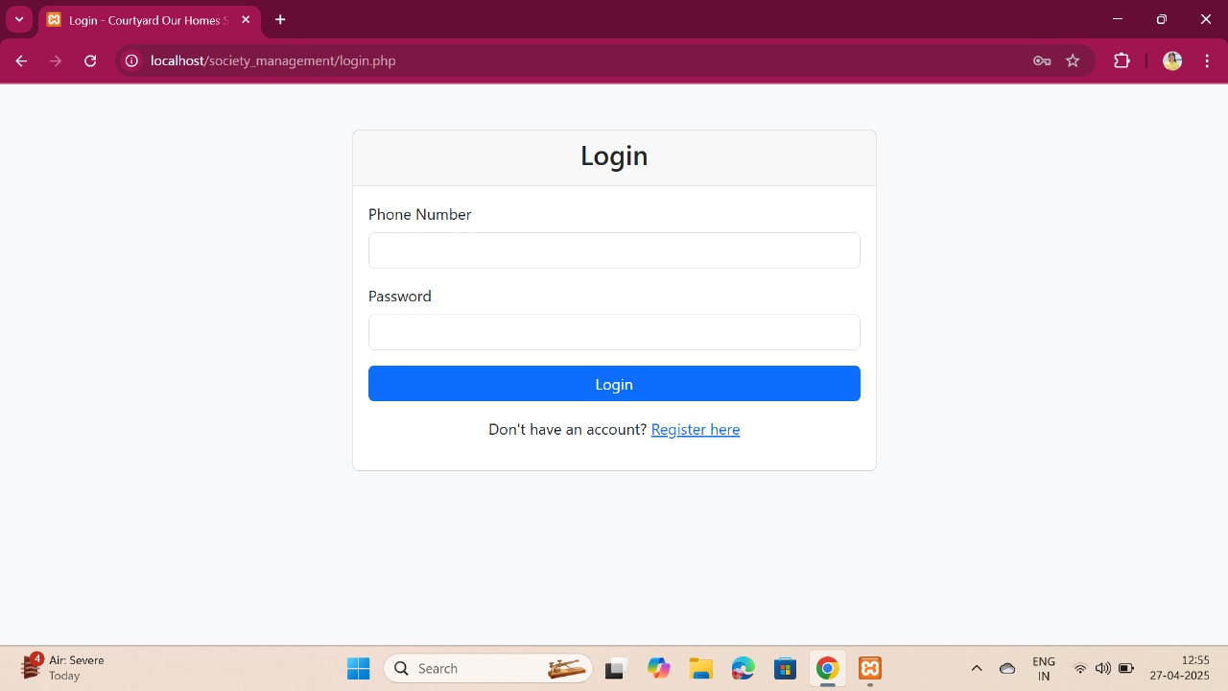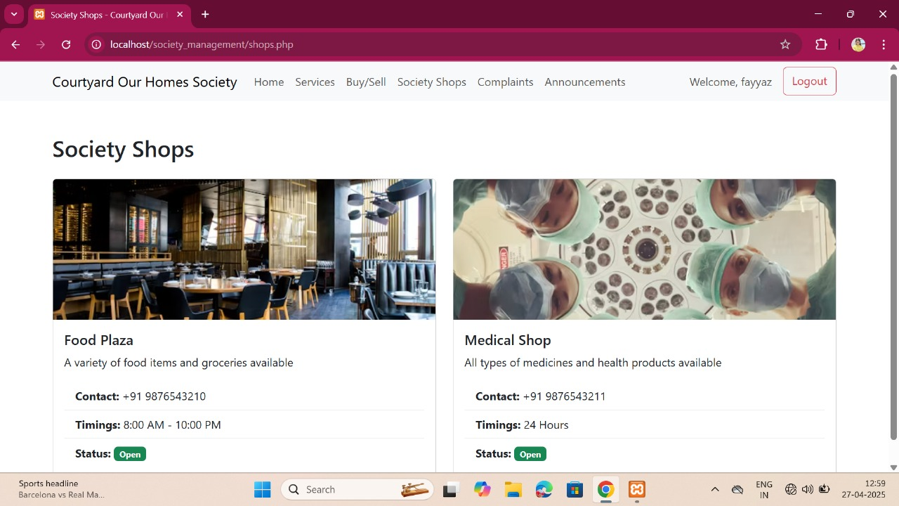

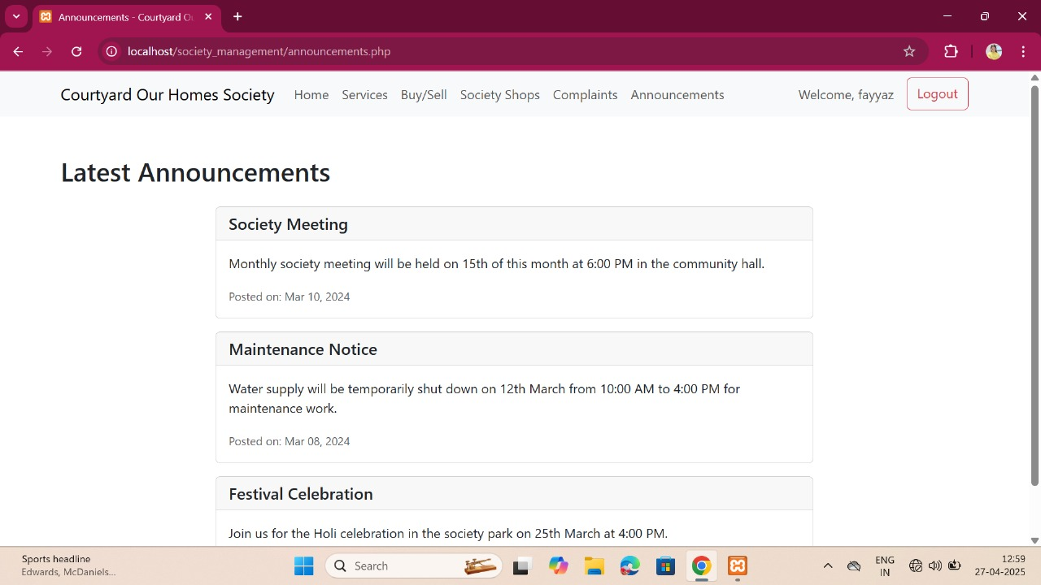 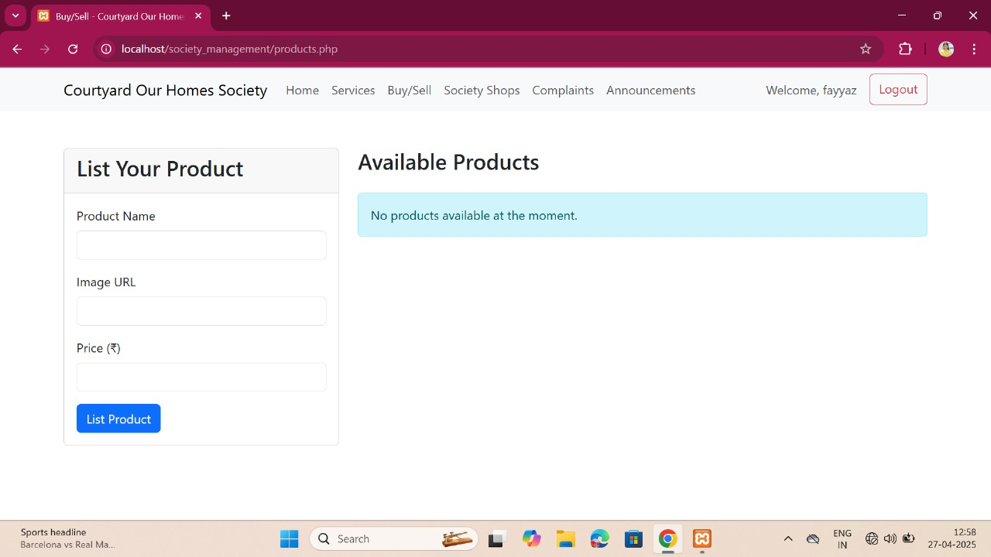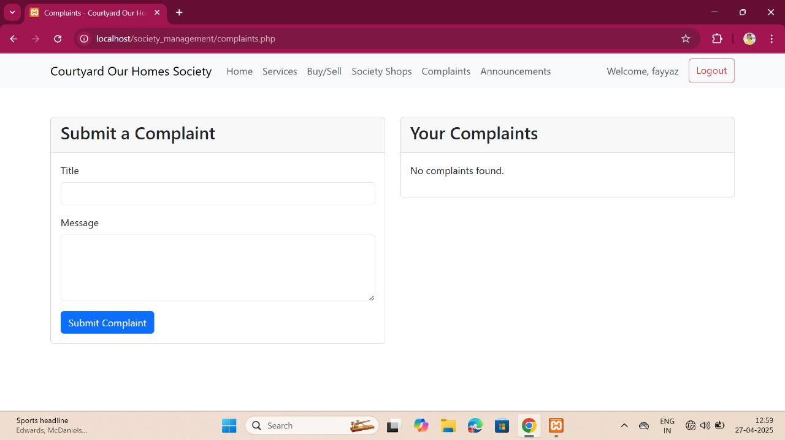

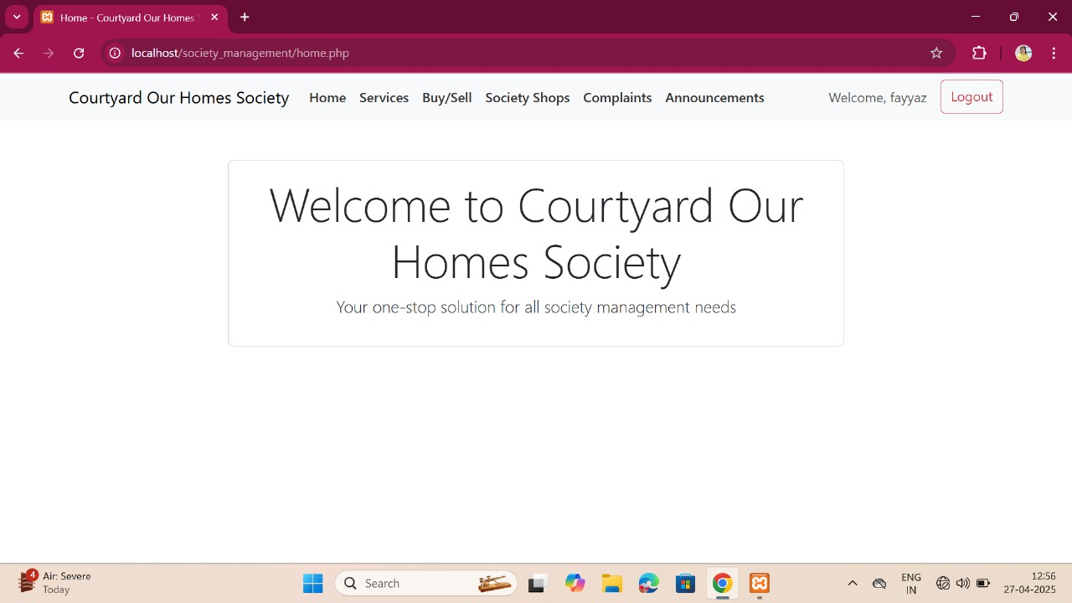

**16.CONCLUSION**

The Society Management app project successfully addresses the major challenges faced in residential society management by offering a **centralized, digital, and user-friendly solution**.  
Through the development of a mobile application using **modern technologies** like Flutter/React Native, Node.js/Django, and Firebase, we have streamlined essential operations such as **service booking, complaint resolution, notifications, and community engagement**.

By adopting an **Agile Methodology**, the project evolved iteratively with constant feedback, ensuring that the app truly meets resident needs and administrative demands.  
The digital approach significantly **reduces communication gaps**, **enhances transparency**, **simplifies service coordination**, and **improves the overall resident experience**.

Moreover, the Society Management app sets the foundation for **smart community living**, encouraging a **more connected, efficient, and engaged residential environment**.  
With future enhancements like IoT integrations, security monitoring, and automated billing systems, the platform has the potential to evolve into a complete **Smart Society Ecosystem**.

Thus, Society Management not only fulfills its initial objectives but also creates a scalable framework for future digital transformations in residential communities.

**FUTURE WORK**

Although the Society Management app covers essential society management functionalities, there are several exciting opportunities to expand and enhance the platform in the future:

## 1. **IoT Integration for Smart Living**

* Integrate IoT devices like smart gates, security cameras, and automated lighting systems.
* Enable residents to monitor security feeds and control devices remotely via the app.

## 2. **Advanced Security Features**

* Implement facial recognition or QR-code based entry systems for visitors and residents.
* Add a panic button feature for emergency alerts directly from the app.

## 3. **AI-based Complaint Management**

* Use machine learning to automatically categorize complaints and suggest quick solutions.
* Prioritize urgent complaints based on keywords and resident feedback.

## 4. **Visitor Management System**

* Introduce a digital gate pass system allowing residents to pre-authorize guest entries.
* Real-time notification to residents when their guests arrive.

## 5. **Bill Management and Automated Payments**

* Extend payment modules to include society maintenance fees, utility bills, and event registrations.
* Enable recurring automated payments and reminders for due bills.

## 6. **Community Marketplace**

* Create an in-app platform for residents to buy, sell, or exchange goods and services locally.

## 7. **Multi-Language Support**

* Add support for regional languages to make the app more accessible to all residents.

## 8. **Analytics Dashboard for Admins**

* Develop a dashboard showing key society metrics (e.g., complaints resolved, service bookings, visitor logs) for better decision-making.

## 9. **Web Application Version**

* Develop a responsive web app so that residents and administrators can access services from desktops and laptops.

**REFERENCES**

• Brown, T. (2020). Smart Community Management: Digital Solutions for Residential Societies. Springer.

• Smith, J., & Patel, R. (2019). Enhancing Residential Living with IoT and Mobile Applications. Journal of Smart City Technologies, 12(3), 45-60.

• Google Developers. (n.d.). Flutter Documentation. Retrieved from <https://flutter.dev/docs>

• Mozilla Developer Network (MDN). (n.d.). Node.js and Backend Development. Retrieved from <https://developer.mozilla.org/>

• Firebase. (n.d.). Firebase Cloud Messaging for Real-time Updates. Retrieved from <https://firebase.google.com/docs>

• Stripe. (n.d.). Online Payment Integration Guide. Retrieved from <https://stripe.com/docs>

• Agile Alliance. (2015). Understanding Agile Development Methodologies. Retrieved from <https://www.agilealliance.org/>